GRE test GR0177 Problems 1-10

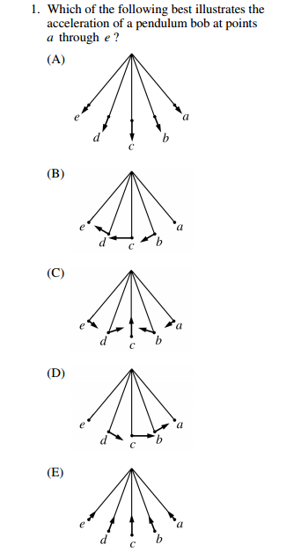

There is both an inward tangential acceleration equal to gsin(theta) and also a normal acceleration along the string inward toward center equal to mv^2/r. Both vary…. But answer C has the only qualitatively correct directions.

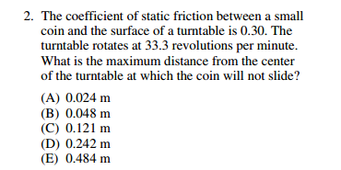

Mu*mg=mv^2/r or m(omega)^2

Recall omega=33.3*2*pi/60.

Do math. D

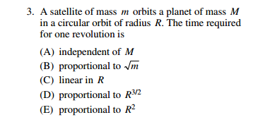

GM/R^2=mv^2/R where v=2piR/T. Get T^2 proportional to R^3….which is keplers third law.

Answer D. Know it or derive very quickly.

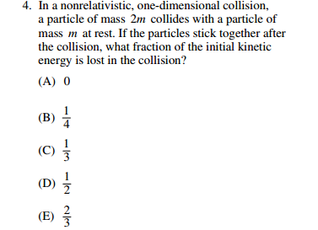

From conservation of momentum,

V(lump after)=(2/3)*v(init).

Now do KE.

½(2m)v^2 for KE(init)

And

½(3m)(2/3 v(init)^2 for KE after.

----2/3 remaining. One third lost. C.

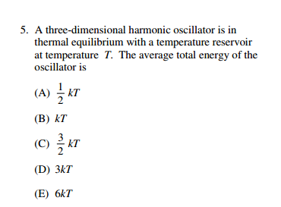

Thermal physics. For a free particle KE can be shared among each of 3 components for velocity. There are 3 degrees of Freedom---so 3/2 kT. These are not free particles. There are three degrees of freedom for velocity, but also potential energy (position x,y, z). So SIX degrees of freedom.

Answer D 3kT.

Average KE proportional to Temp= n*(1/2)k T. where n is number of degrees of freedom. Energy spreads out amongst available states.

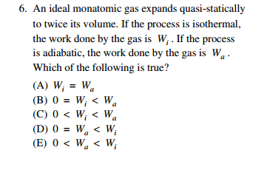

Quasi Static means well defined macroscopic properties---P, V, T.

Isothermal…const T. Adiabatic no time for heat exchange.

Consider that piston again.
In an expansion the gas tends to cool since it is doing work and thus losing energy. If the process is isothermal, heat must be added through the walls to keep T constant. In the adiabatic case no heat is added, so at any volume along the way, the temperature is less than the isothermal case. This also means in the adiabatic case the pressure of the gas will be less at the same volume. Both cases must pass through all the same volumes In order to get piston with mass to rise, I must reduce the mass on the piston in order to lift it to the same final value of volume in the adiabatic case. Hence the adiabatic case has less work done. Answer E.

---NOTE I stuck with a completely conceptual understanding.
-----

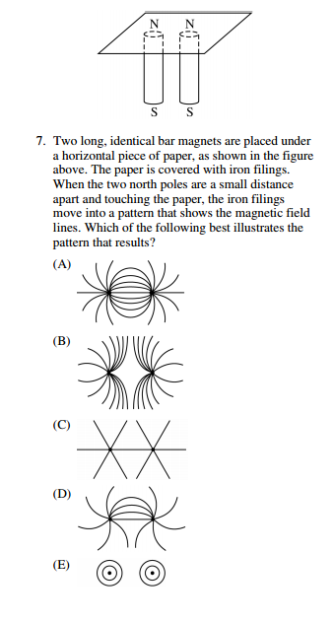

Answer B. Think about it. Like two positive charges.

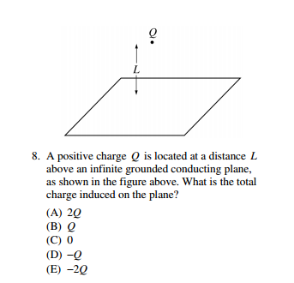

Answer D. Image charge---coming soon.

Think about how field lines hit conducting plate (perpendicular) and you will see a half dipole picture. The other half (terminating field lines) represents a negative charge with just as much total number of field lines terminating as come out of the positive charge.

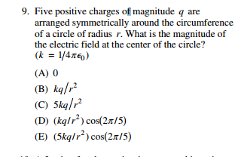

Zero

Answer A.

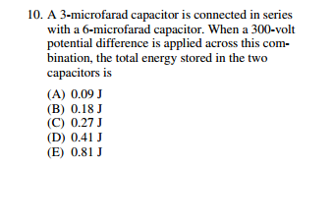

C(eff)=1/(1/3+1/6)=2microF

Energy =1/2C V^2

2/2 *(300)^2 ….answer A is the only 9x10^?????

